TASK 3 – WAN Technologies

- Write a short scenario where a user tries to access a private Wi-Fi network (like at a campus or airport) and describe how each of the three AAA functions—Authentication, Authorization, and Accounting—would apply step by step in this situation.
Ans.
Scenario: Accessing a Private Campus Wi-Fi Network
A student named Rahul wants to connect his laptop to the private Wi-Fi network at his college campus. When he selects the campus Wi-Fi, he is asked to enter his username and password. The network uses AAA (Authentication, Authorization, and Accounting) to control access.

- Authentication
Authentication verifies the identity of the user.
- Rahul enters his username and password.
- The Wi-Fi server checks the credentials against its database.
- If the username and password are correct, Rahul is authenticated and allowed to log in.
- If the credentials are incorrect, access is denied.
Purpose: To confirm that the user is a valid student authorized to use the campus Wi-Fi.

2. Authorization
Authorization determines what resources the authenticated user can access.
- After successful login, the network checks Rahul's access permissions.
- As a student, he is allowed to access the internet, online learning portals, and library resources.
- He is not allowed to access administrative or staff-only systems.
Purpose: To ensure users can access only the resources they are permitted to use.

3. Accounting
Accounting records the user's network activities.
- The network logs Rahul's login time, logout time, IP address, and data usage.
- These records help the college monitor network usage and troubleshoot issues.
- The information can also be used for security audits.
Purpose: To keep a record of user activity and resource usage on the network.

- Create a table comparing at least two different AAA deployment models (such as centralized vs distributed), listing three advantages and three disadvantages of each for a company like Zomato that handles sensitive user data.
Ans.
Feature | Centralized AAA | Distributed AAA
Definition | All authentication, authorization, and accounting services are managed from a central server. | AAA services are managed by multiple servers located in different locations.
Advantage 1 | Easier management because all user accounts are stored in one place. | Faster authentication because users connect to a nearby server.
Advantage 2 | Consistent security policies across the entire company. | Continues to operate even if one server fails.
Advantage 3 | Easier monitoring and auditing of user activities. | Better scalability for large organizations with many branches.
Disadvantage 1 | Single point of failure if the central server goes down. | More complex to configure and manage.
Disadvantage 2 | Higher network traffic due to all requests going to one server. | Security policies may become inconsistent across locations.
Disadvantage 3 | May experience slower response times for remote offices. | Higher deployment and maintenance costs.

Which Model is Better for Zomato?
Zomato handles sensitive customer data, online payments, and restaurant information across many locations. A Distributed AAA model is often preferred because it provides better availability, scalability, and faster authentication for users and employees in different regions. However, it requires careful management to maintain consistent security policies.

- Draw a simple network diagram (can be hand-drawn and photographed) showing how AAA servers are integrated into a typical enterprise network for user access control, labeling where Authentication, Authorization, and Accounting processes happen.
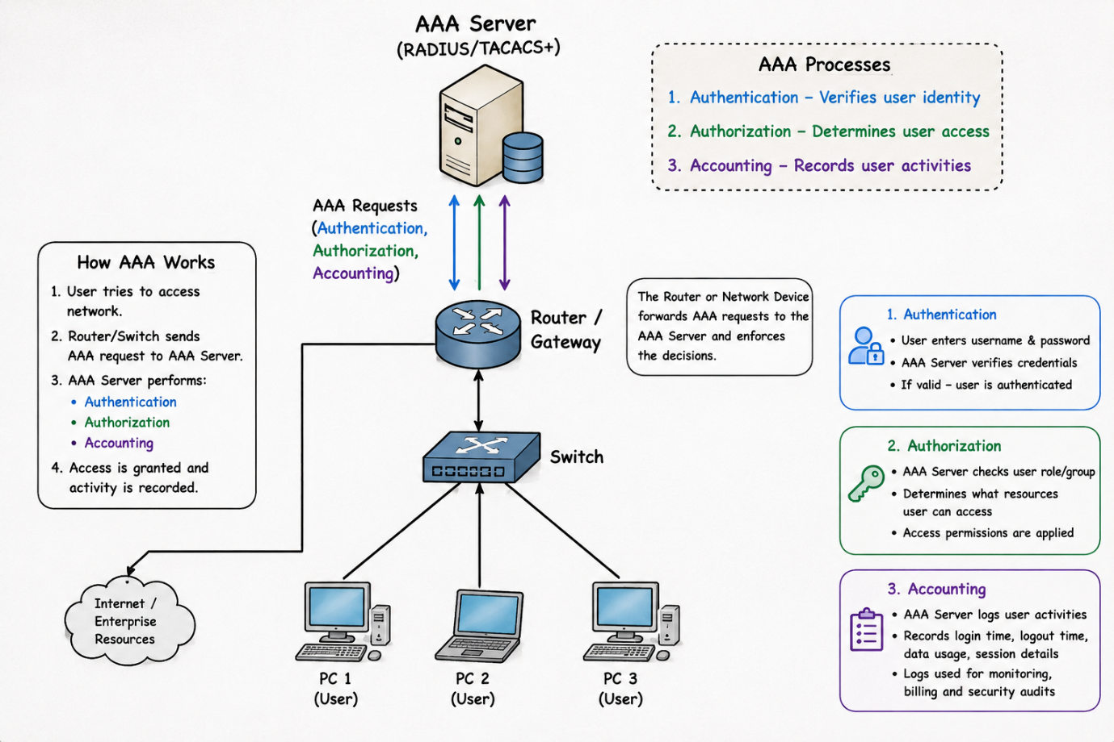

AAA Server Integration in an Enterprise Network
The above diagram shows how an AAA (Authentication, Authorization, and Accounting) server is integrated into an enterprise network to control user access.
When a user connects to the network through a PC, the request is sent through the switch and router to the AAA server. The AAA server then performs the three AAA functions:
1. Authentication
Authentication verifies the identity of the user.
- The user enters a username and password.
- The AAA server checks the credentials.
- If the credentials are correct, the user is allowed to access the network.
- If the credentials are incorrect, access is denied.
2. Authorization
Authorization determines what resources the user can access.
- After successful authentication, the AAA server checks the user's permissions.
- It decides which applications, servers, or network resources the user can use.
- Different users may have different access levels.

3. Accounting
Accounting records the user's network activities.
- The AAA server stores login and logout times.
- It records data usage and session details.
- These logs help with monitoring, auditing, and troubleshooting.

- Pick any app you use daily (Instagram, Paytm, or Flipkart) and write a paragraph explaining how AAA concepts could be applied to secure user logins and actions within that app.
Ans. AAA Concepts in Instagram (Step-by-Step)

Step 1: Authentication
- The user opens Instagram.
- The user enters their username, email, phone number, and password.
- Instagram checks the credentials.
- If the details are correct, the user is logged in.
- If the details are incorrect, access is denied.

Step 2: Authorization
- After login, Instagram checks the user's permissions.
- The user can view posts, upload photos, send messages, and edit their profile.
- The user cannot access private data or settings of other users.
- Access is granted based on the user's account permissions.

Step 3: Accounting
- Instagram records the user's activities.
- It stores login time, logout time, device information, likes, comments, and posts.
- These records help monitor account activity and improve security.
- The logs can also help detect suspicious login attempts.

- Use ChatGPT or any AI tool to generate a sample AAA policy for a college WiFi network that restricts access to students only, allows certain websites, and logs all access attempts. Paste the generated policy and briefly explain how each AAA function is addressed.
Ans. Sample AAA Policy for a College WiFi Network

Policy Name: College Student WiFi Access Policy

- Only registered students with valid college usernames and passwords are allowed to access the college WiFi network.
- Students must authenticate using their college-issued credentials before gaining network access.
- Access is permitted only to educational and approved websites such as:
- College Portal
- Google Classroom
- Microsoft Teams
- Educational websites and online learning platforms
- Access to unauthorized, harmful, or restricted websites is blocked by the network administrator.
- User activities, login attempts, login times, logout times, and internet usage are recorded and monitored.
- Failed login attempts are logged and may be investigated for security purposes.
- Students who violate the acceptable use policy may have their network access restricted or removed.
- All users must comply with the college's IT and cybersecurity guidelines.

How AAA Functions Are Addressed

1. Authentication
- Students must enter their college username and password.
- The system verifies the credentials before granting access.
- Only authorized students can connect to the WiFi network.

2. Authorization
- After successful login, students are allowed to access approved educational websites and services.
- Access to restricted websites is denied.
- Different permissions can be applied based on user roles.

3. Accounting
- The network records login and logout times.
- Internet usage and website access are logged.
- Failed login attempts are tracked for security and auditing purposes.

